Lesson 1: Distributions and Their Shapes
Statistics is all about data. Without data to talk about or to analyze or to question, statistics would not exist. There is a story to be uncovered behind all data - a story that has characters, plots, and problems in the data. The questions or problems addressed by the data and their story can be disappointing, exciting, or just plain ordinary! This module is about stories that begin with data.
Classwork
Example 1: Graphs
Data are often summarized by graphs; the graphs are the first indicator of variability in the data.

Dot plots: A plot of each data value on a Box plots: (Box-whisker plot) A graph that provides a
scale or number line. picture of the data ordered and divided into four
intervals that each contains approximately 25% of the data.

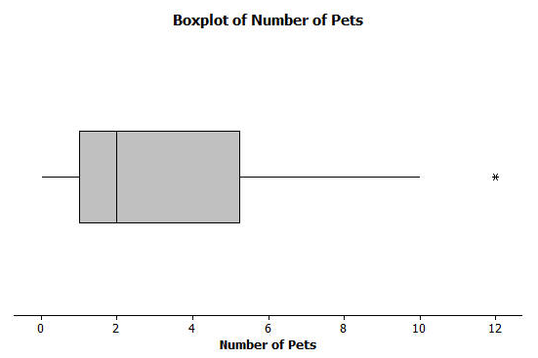
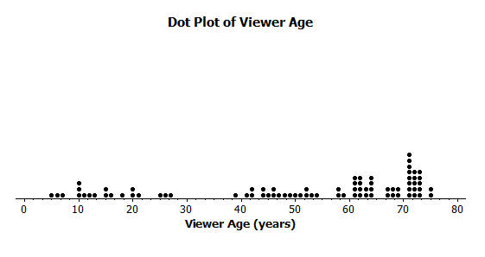

Histograms: A graph of data that groups the data based on intervals and represents the data
in each interval by a bar.
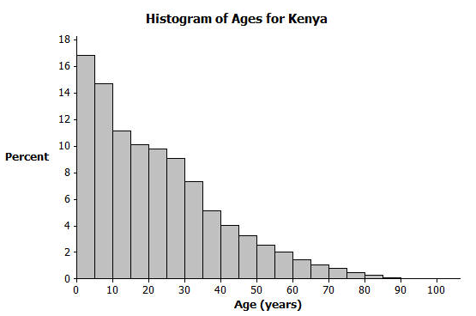

Grouping Data into a Table to make a Histogram
A teacher marked a set of 32 test papers. The grades earned by the students were as follows:
90, 85, 74, 86, 65, 62, 100, 95, 77, 82, 50, 83, 77, 93, 73, 72,
98, 66, 45, 100, 50, 89, 78, 70, 75, 95, 80, 78, 83, 81, 72, 75

Make a histogram for the data given.

Rules to follow when setting up intervals:
- The interval must cover the complete range of values
- The interval must be equal in size
- The number of intervals should be between 5 and 15
- Every data value to be tallied must fall into one and only one interval
- The intervals must be in order least to greatest or greatest to least

Interval | Tally | Frequency

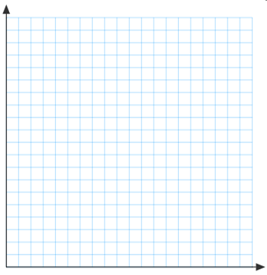
Exercises
Answer the questions that accompany each graph to begin your understanding of the story behind the data.
Transportation officials collect data on flight delays (the number of minutes past the scheduled departure time that a flight takes off).  Consider the dot plot of the delay times for sixty Big Air flights during December 2012.  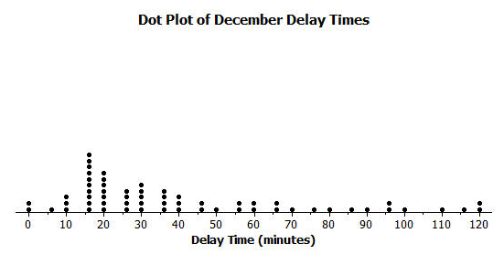 | - What do you think this graph is telling us about the flight delays for these sixty flights?  - Can you think of a reason why the data presented by this graph provides important information? Who might be interested in this data distribution?  - Based on your previous work with dot plots, would you describe this dot plot as representing a symmetric or a skewed data distribution? (Recall that a skewed data distribution is not mound shaped.) Explain your answer.
A random sample of eighty viewers of a television show was selected. The dot plot below shows the distribution of the ages (in years) of these eighty viewers.  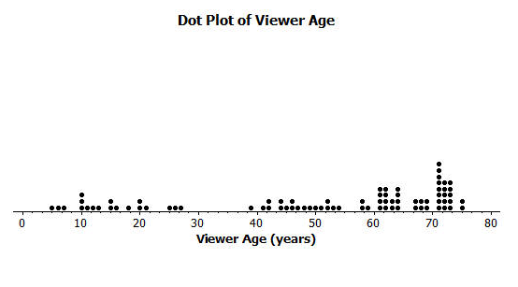 | - What do you think this graph is telling us about the ages of the eighty viewers in this sample?  - Can you think of a reason why the data presented by this graph provides important information? Who might be interested in this data distribution?  - Based on your previous work with dot plots, would you describe this dot plot as representing a symmetric or a skewed data distribution? Explain your answer.
The following histogram represents the age distribution of the population of Kenya in 2010.  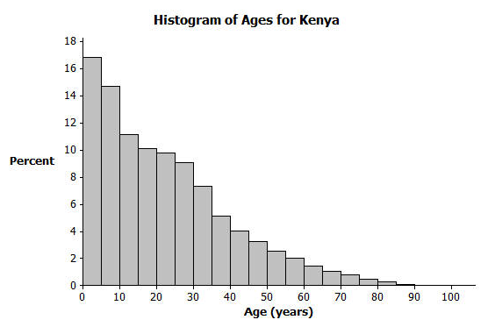 | - What do you think this graph is telling us about the population of Kenya?  - Why might we want to study the data represented by this graph?  - Based on your previous work with histograms, would you describe this histogram as representing a symmetrical or a skewed distribution? Explain your answer.
The following histogram represents the age distribution of the population of the United States in 2010.  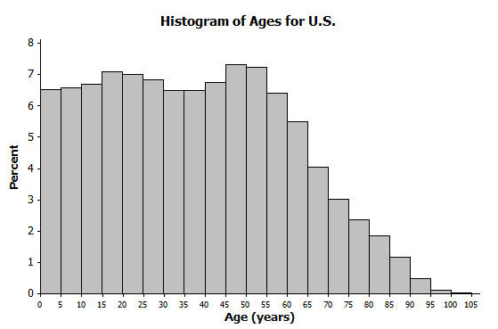 | - What do you think this graph is telling us about the population of the United States?  - Why might we want to study the data represented by this graph?
Thirty students from River City High School were asked how many pets they owned. The following box plot was prepared from their answers.  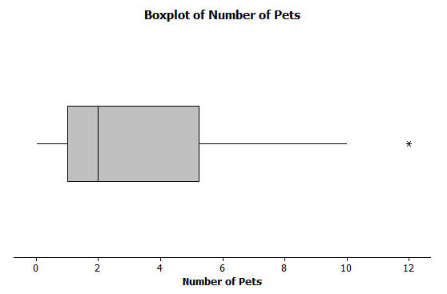 | - What does the box plot tell us about the number of pets owned by the thirty students at Rivers City High School?  - Why might understanding the data behind this graph be important?
Twenty-two juniors from River City High School participated in a walkathon to raise money for the school band. The following box plot was constructed using the number of miles walked by each of the twenty-two juniors.  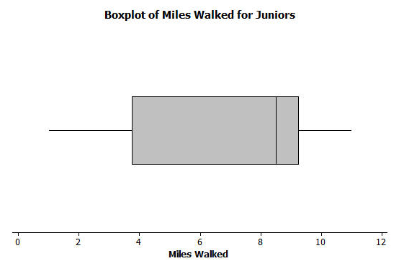 | - What do you think the box plot tells us about number of miles walked by the twenty-two juniors?  - Why might understanding the data behind this graph be important?

Lesson Summary
Statistics is about data. Graphs provide a representation of the data distribution and are used to understand the data and to answer questions about the distribution.

Problem Set

- Twenty-five people were attending an event. The ages of the people are indicated below:
3, 3, 4, 4, 4, 4, 5, 6, 6, 6, 6, 6, 6, 6, 7, 7, 7, 7, 7, 7, 16, 17, 22, 22, 25
  - Create a histogram of the ages using the provided axes.

Interval | Tally | Frequency
0-5
6-10
11-15
16-20
21-25
26-30
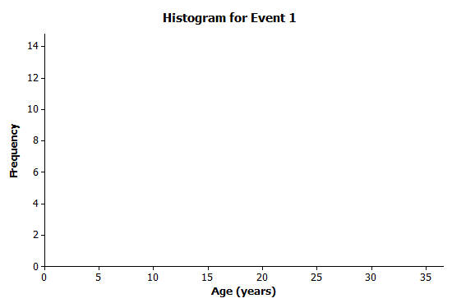

  - Would you describe your graph as symmetrical or skewed? Explain your choice.

  - Identify a typical age of the twenty-five people.

  - What event do you think the twenty-five people were attending? Use your histogram to justify your conjecture.

- A different group of forty people were also attending an event. The ages of the people are:

6, 13, 24, 27, 28, 32, 32, 34, 38, 42, 42, 43, 48, 49, 49, 49, 51, 52, 52, 53,
53, 53, 54, 55, 56, 57, 57, 60, 61, 61, 62, 66, 66, 66, 68, 70, 72, 78, 83, 97

  - Create a histogram of the ages using the provided axes.
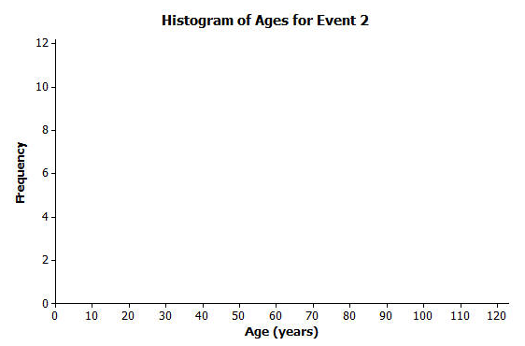
Interval | Tally | Frequency
0-10
11-20
21-30
31-40
41-50
51-60
61-70
71-80
81-90
91-100

  - Would you describe your graph of ages as symmetrical or skewed? Explain your choice.

  - Identify a typical age of the forty people.

  - What event do you think the forty people were attending? Use your histogram to justify your conjecture.

  - How would you describe the differences in the two histograms?

